Technical Architecture for AI Nutrition

Nasui Elisa
Singh Parisdeep

Main architecture:
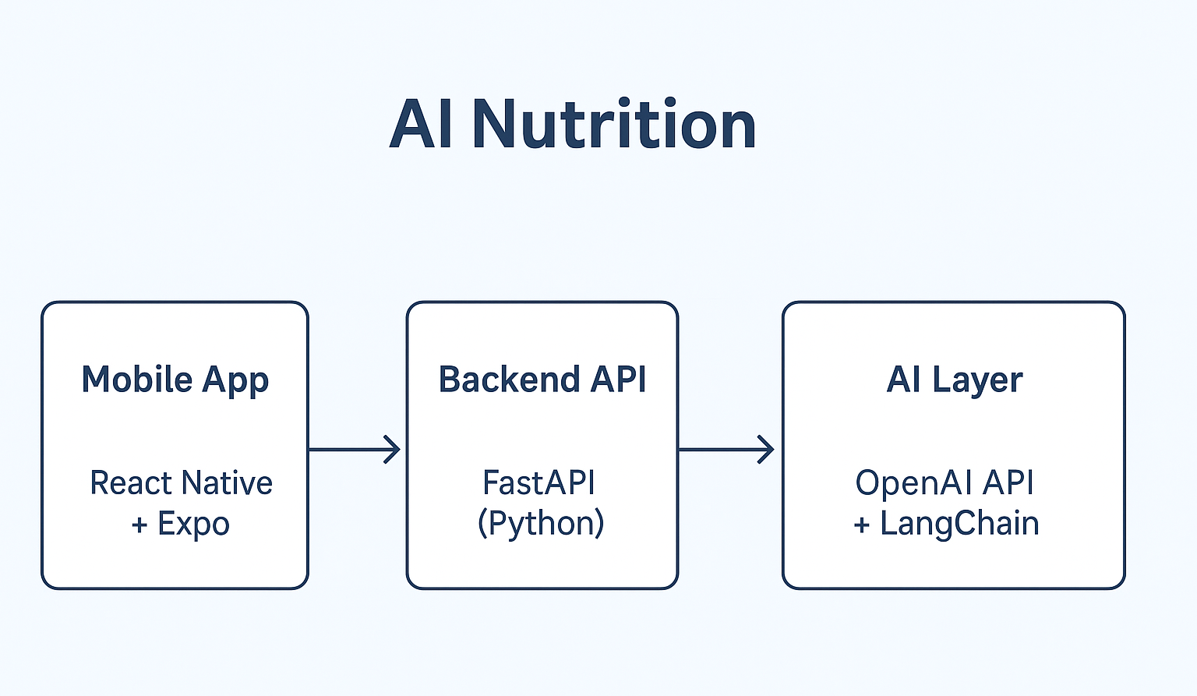

1. General Architecture
[Frontend (React Native + Expo)]
↓
[Backend (FastAPI)]
↓
[AI Layer (OpenAI API / LangChain)]
↓
[Database (PostgreSQL + Redis)]

2. Frontend Framework: React Native + Expo
Interface features:
• Chat interface (Q&A with AI)
• User profile (nutritional information)
• Conversation history
• “Suggestions” section
• Daily push notifications
Expo is a tool that greatly simplifies React Native:
• It allows you to easily test the app on your phone
• It manages permissions (camera, notifications, etc.)
• It allows easy publishing on the Play Store / App Store (even if not needed immediately)
Smooth interface, easily connectable to a REST API (FastAPI).
Possible integration with a chat-like UI (libraries such as react-native-gifted-chat) — it’s a message interface similar to WhatsApp.
One single codebase for both iOS and Android.

3. Backend : FastAPI (Python)
• Very fast and modern.
• Natural integration with AI APIs (OpenAI, Hugging Face, etc.) (useful for our AI integration use case)
• Easy to deploy on cloud services.
• Ideal for handling logic such as:
-Routing user requests
-Authentication
-Communication with AI
-Database storage

4. Artificial Intelligence
OpenAI API (GPT-4 or GPT-4o-mini) for text generation.
LangChain or LlamaIndex for managing scientific documents and retrieval.
How it works:
- The user sends a question.
- The backend builds a prompt:
-role = nutrition coach
-context = scientific documents + user profile
- LangChain searches for relevant passages in the documents.
- GPT-4 generates a structured and reliable answer.
Possibility to add RAG (Retrieval-Augmented Generation) to answer only from validated sources.

5. Database: PostgreSQL
• Robust, free, open-source relational database.
• Stores:
-User profiles
-Conversation history
-Feedback (useful/not useful)
-Meal information
Optional complement: Redis
Ultra-fast in-memory cache to:
-Temporarily store conversations
-Manage user sessions
-Speed up frequent queries

6. Security & Compliance
Authentication via JWT tokens
Encrypted personal data (user profiles)
GDPR compliance: no sensitive data sent to OpenAI without consent
Minimal storage of conversations (anonymized)

7. Stack Summary
Layer | Technology | Explanation
Frontend | React Native + Expo | Multi-platform, smooth UI
Backend | FastAPI (Python) | Speed, simplicity, AI integration
AI Layer | OpenAI API + LangChain | Natural and reliable answers
Database | PostgreSQL (+ Redis) | Structured data + performance
Auth | JWT | Secure and standard
Hosting | Render / Railway / Supabase | Fast and scalable deployment

Example of User Flow
- The user opens the app and logs in.
- They type: “What should I eat after working out?”
- FastAPI → sends the request to GPT-4 with internal documents.
- The AI returns a personalized response based on their profile.
- The user rates the answer (useful/not useful).
- The data is stored in PostgreSQL for continuous improvement.

